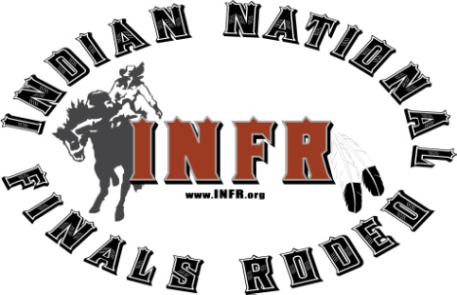

Assumption of Risk and Liability
2018 INFR

B1.2.4. Assumption of Risk and Release of Liability by becoming a member of the INFR, you are agreeing to release the INFR and other parties from liability.
Please read over carefully.
Members acknowledge that rodeo events are inherently dangerous activities. Members further acknowledge that participation in an INFR event exposes the participant to substantial and serious hazards and risks of property damage, personal injury and/or death. Each member, in consideration of his/her membership in the INFR and his/her being permitted to participate in an INFR sanctioned event in any capacity, does by such memberships, waive, release, and covenant not to sue INFR, INFR Properties, all INFR sponsor, all members (including without limitation, contestants, stock contractor, rodeo committees, rodeo producers, and contract personnel), and any other INFR sanctioned event production entity, from all claims, demand and liabilities that are known or unknown, foreseen or unforeseen, future or contingent and includes, claims, demands and liabilities arising out of the negligence of the parties so released by such member. Furthermore, where permitted by applicable law, this discharge, waiver and release also includes claims, demands, and liabilities arising out of the gross negligence or willful and wanton negligence of the parties so released. This discharge waiver and release also includes claims, demands, and liabilities by a member for indemnities and contributions arising from property damage, personal injury and/or death to a third party. In the event that any provision of this discharge, waiver and release is determined to be invalid for any reason, such invalidity shall not effect the validity of any of the other provisions, which other provisions shall remain in full force and effect as if this discharge, waiver, and release has been executed with the invalid provision eliminated.
The undertakings and covenants of the forgoing provisions shall be binding upon each member, his or her heirs, legal representatives, successors and assigns
B1.2.5 Indemnification: Each member agrees to indemnify and save and hold harmless INFR, and all INFR sponsors from any and all claims, demands, and liabilities for any and all property damage, personal injury, and/or death asserted by a third party and arising from such members participation in an INFR sanctioned event.

I have read and agree to the 2018 Indian National Finals Rodeo Assumption of Risk and Liability.

I will attain a copy from www.infr.org and read the 2018 Indian National Finals Rodeo Ground Rules and/or JR./SR. Ground Rules.

Printed Name of Contestant: ____________________________________________Date: _____________________

Signature of Contestant: ________________________________________________Date: ____________________

Printed Name of Parent: ________________________________________________Date: ____________________
(if under age of 18 yrs.)

Signature of Parent: __________________________________________________ Date: _____________________

